AI Finance Advisor Project
Subbarao V

System Architecture & Agent Workflow

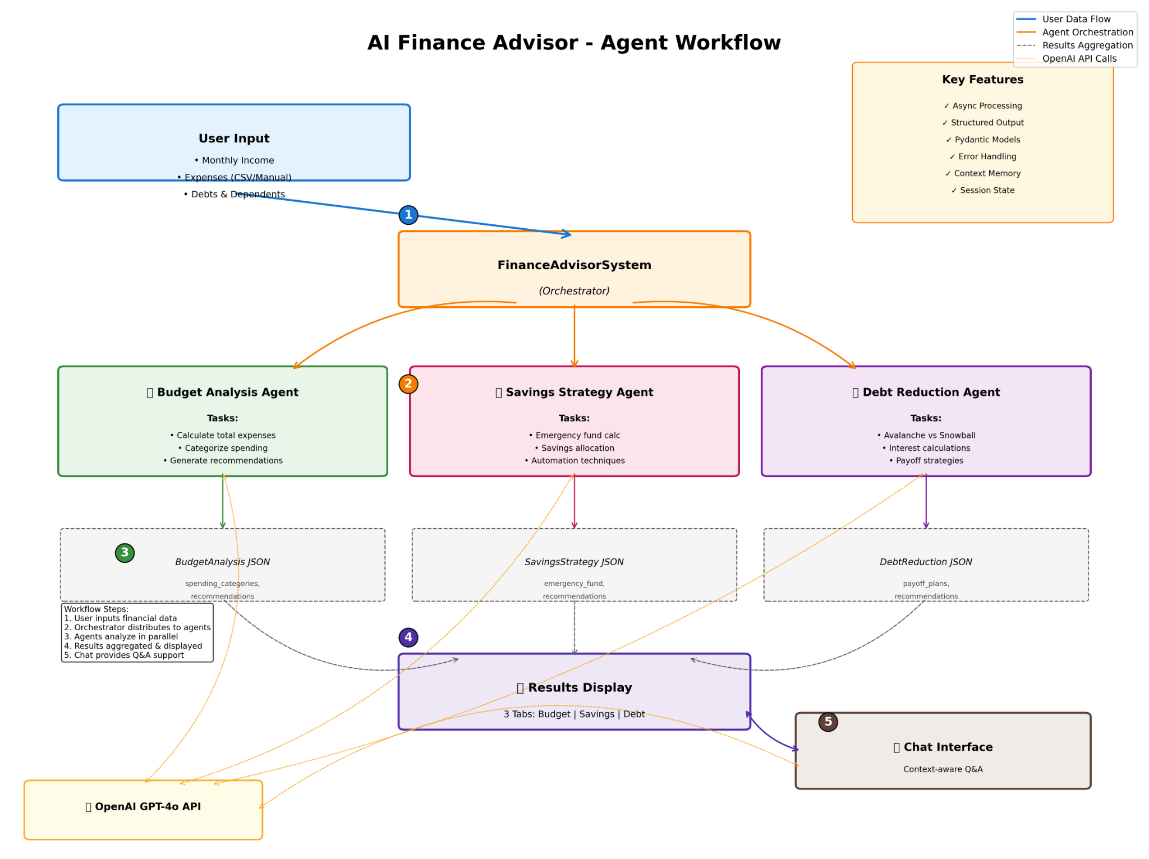
Figure: AI Finance Advisor – Agent-Based Workflow

1. Introduction
Managing personal finances effectively requires continuous monitoring of income, expenses, savings, and debts. Many individuals find it difficult to convert raw financial data into meaningful insights. The AI-Powered Personal Finance Advisor addresses this challenge by using Large Language Models (LLMs) to analyze user financial data and generate personalized, actionable recommendations.

2. Objectives
The objectives of this project are:
• Analyze income, expenses, dependants, and debts
• Provide category-wise budget analysis
• Recommend savings strategies and emergency funds
• Optimize debt repayment using avalanche and snowball methods
• Enable conversational financial guidance

3. System Architecture
The system follows an agent-based architecture orchestrated by a central FinanceAdvisorSystem. User data is processed asynchronously and distributed to specialized agents. Each agent focuses on a specific financial task and returns structured JSON outputs, which are aggregated and visualized for the user.

4. Key Modules
• Budget Analysis Agent: Calculates expenses, categorizes spending, and provides optimization tips.
• Savings Strategy Agent: Determines emergency fund requirements, savings allocations, and automation methods.
• Debt Reduction Agent: Evaluates debts and generates optimized payoff plans.
• Chat Interface: Provides context-aware financial Q&A.

5. Technologies Used
• Python
• Streamlit (UI)
• OpenAI GPT-4o API
• Plotly for data visualization
• Pydantic for structured outputs
• Async processing and session management

6. Results and Discussion
The system successfully converts raw financial data into structured insights. By combining deterministic calculations with LLM-based reasoning, the application provides accurate, explainable, and user-friendly financial advice.

7. Conclusion and Future Scope
This project demonstrates the effective use of AI agents in personal finance management. Future enhancements may include investment planning, tax optimization, bank API integrations, and long-term financial forecasting.

